W1801R-How to setup the USB Storage?
Product line: Wireless question category: function config

1.Plug in your USB Storage in the USB port of the router.
2. Open a browser or safari, then input 192.168.0.1 in the address bar, click Enter.
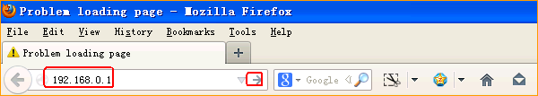
2.Input admin, admin, click Login.
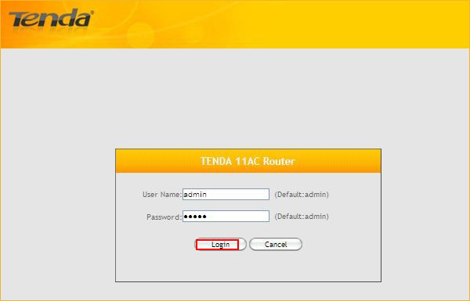

3.Click Advanced.

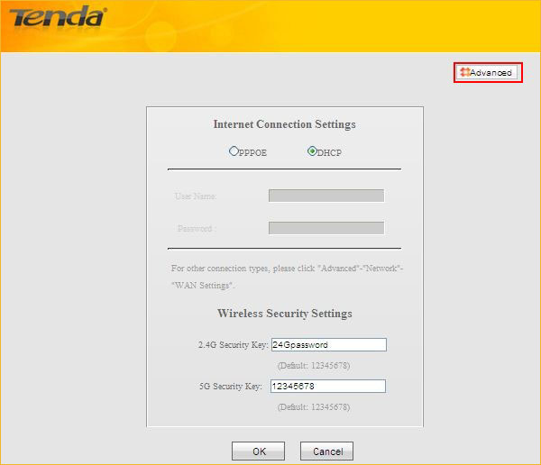

4.Click on USB, choose the right for your file, click Add and set a name and password for your USB Storage.
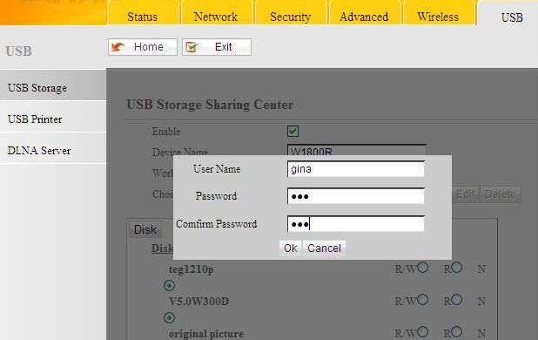

5. Open My Computer on the desktop of the computer which is connected to this router, then input \\ 192.168.0.1 in the address bar, then you can see the files of the USB storage.

